**US Election 2024: America Has Spoken**

**Dr Michael Green | CEO | United States Studies Centre Australia**

**Monday 25 November 2024: 5:30pm for 6 – 7pm AEDT at Level 13, 356 Collins Street, Melbourne VIC 3000**

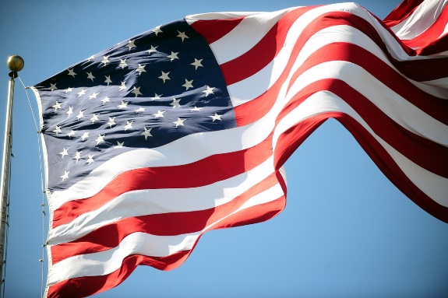What are the implications of the result of the US election?  What do the results of the Presidential, Senate and House elections mean for the USA? For the global economy? And for Australia?

AIIA Victoria invites you to join United States Studies Centre CEO Dr Michael Green to review the outcome of this extraordinary election.

*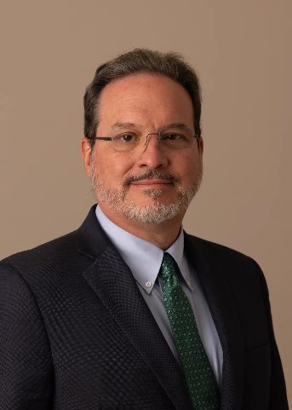Dr Michael Green is professor and chief executive officer at the United States Studies Centre in Sydney.*

*Previously Dr Green was Senior Vice President for Asia at the Center for Strategic and International Studies (CSIS) and is on leave from Georgetown University where he was Director of Asian Studies and Chair in Modern and Contemporary Japanese Politics and Foreign Policy at the Edmund A. Walsh School of Foreign Service. He served on the staff of the National Security Council (NSC) at the White House from 2001 through 2005, first as Director for Asian Affairs and then as Special Assistant to the President for National Security affairs and Senior Director for Asia. Before joining the NSC staff, he held positions at the Council on Foreign Relations, the School of Advanced International Studies (SAIS) at Johns Hopkins University, the Institute for Defense Analyses, and the Office of the Secretary of Defense. He also worked in Japan on the staff of a member of the National Diet.*

*Dr Green is currently also Senior Advisor (non-resident) and Henry A. Kissinger Chair at CSIS and Distinguished Guest Scholar at the Asia Pacific Initiative in Tokyo. He serves on the boards of The Asia Foundation and Radio Free Asia, the advisory board of the Center for a New American Security and the Advisory Council of the Bush Institute, and as Senior Adviser to The Asia Group. He is a member of the Council on Foreign Relations and the Aspen Strategy Group.*

*Dr Green has authored numerous books and articles on Indo-Pacific security, including most recently*[*Line of Advantage: Japan’s Grand Strategy in the Era of Abe Shinzō*](https://cup.columbia.edu/book/line-of-advantage/9780231204675)*(Columbia University Press, 2022), recommended by Foreign Affairs as one of the top three books on Asia for that year, and* By More Than Providence: Grand Strategy and American Power in the Asia Pacific Since 1783*(Columbia University Press, 2017), which won the Council on Foreign Relations Arthur Ross Silver Medal for best book in international affairs.*